GIS Application

NCGSA Internship – week 3

1/8/22 | IST NAV App development | Mam Aneeqa

Kiran Sardar | 200901064

Syeda Farwa Rizvi | 200901098

# Literature Review

In the 3rd week, we worked on the ideal design for UI/UX on Figma. And Created our first draft home page.

## UI/UX Design Idea

Figma is an interactive browser-based interaction design tool, with extra offline functionalities offered by desktop programs for macOS and Windows.

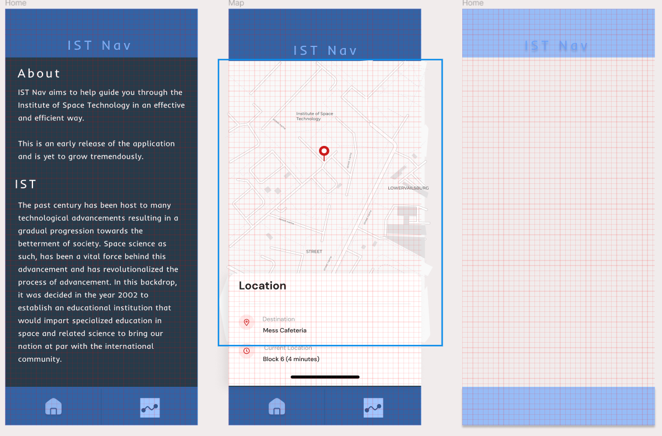

i) there will be 2 basic pages, Home Page and Maps Page

## Basic Home page developed

ii) Home page first draft – functioning scroll view

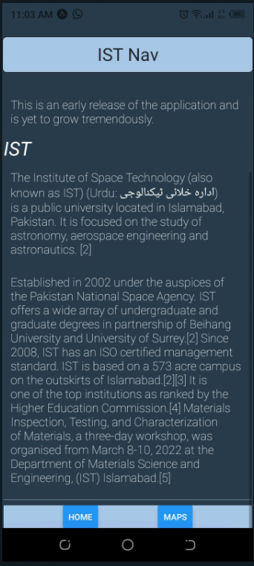

iii) Home page 2nd draft - functioning scroll view and implementing CSS

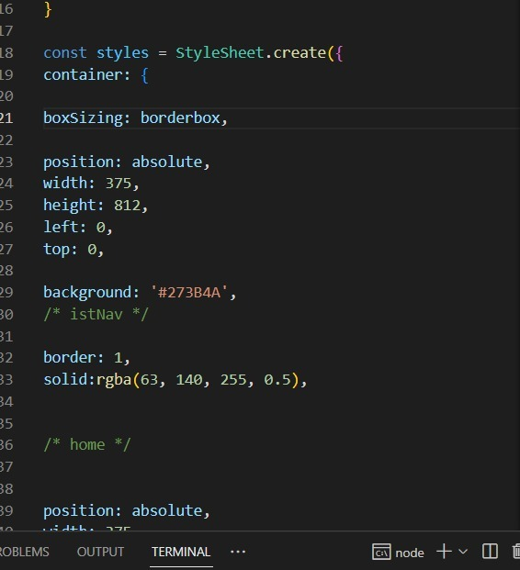

iv)Backend codings example